

**Artificial Intelligence and Data Science Department.**

OS / Even Sem 2021-22 / Experiment 1.

**___________________________________________________**

YASH SARANG.

47 / D6AD.

EXPERIMENT - 1.

Linux Commands and system calls

**___________________________________________________**

**Aim:** Exploring basic commands of Unix/LinuxGeneral Purpose Utilities, Working With Directories File Handling Commands, Changing File Attributes, Exploring basic commands of Unix/LinuxSimple Filters, Pattern matching, Advanced pattern matching, Creating and managing the group.

**___________________________________________________**

**Theory:**

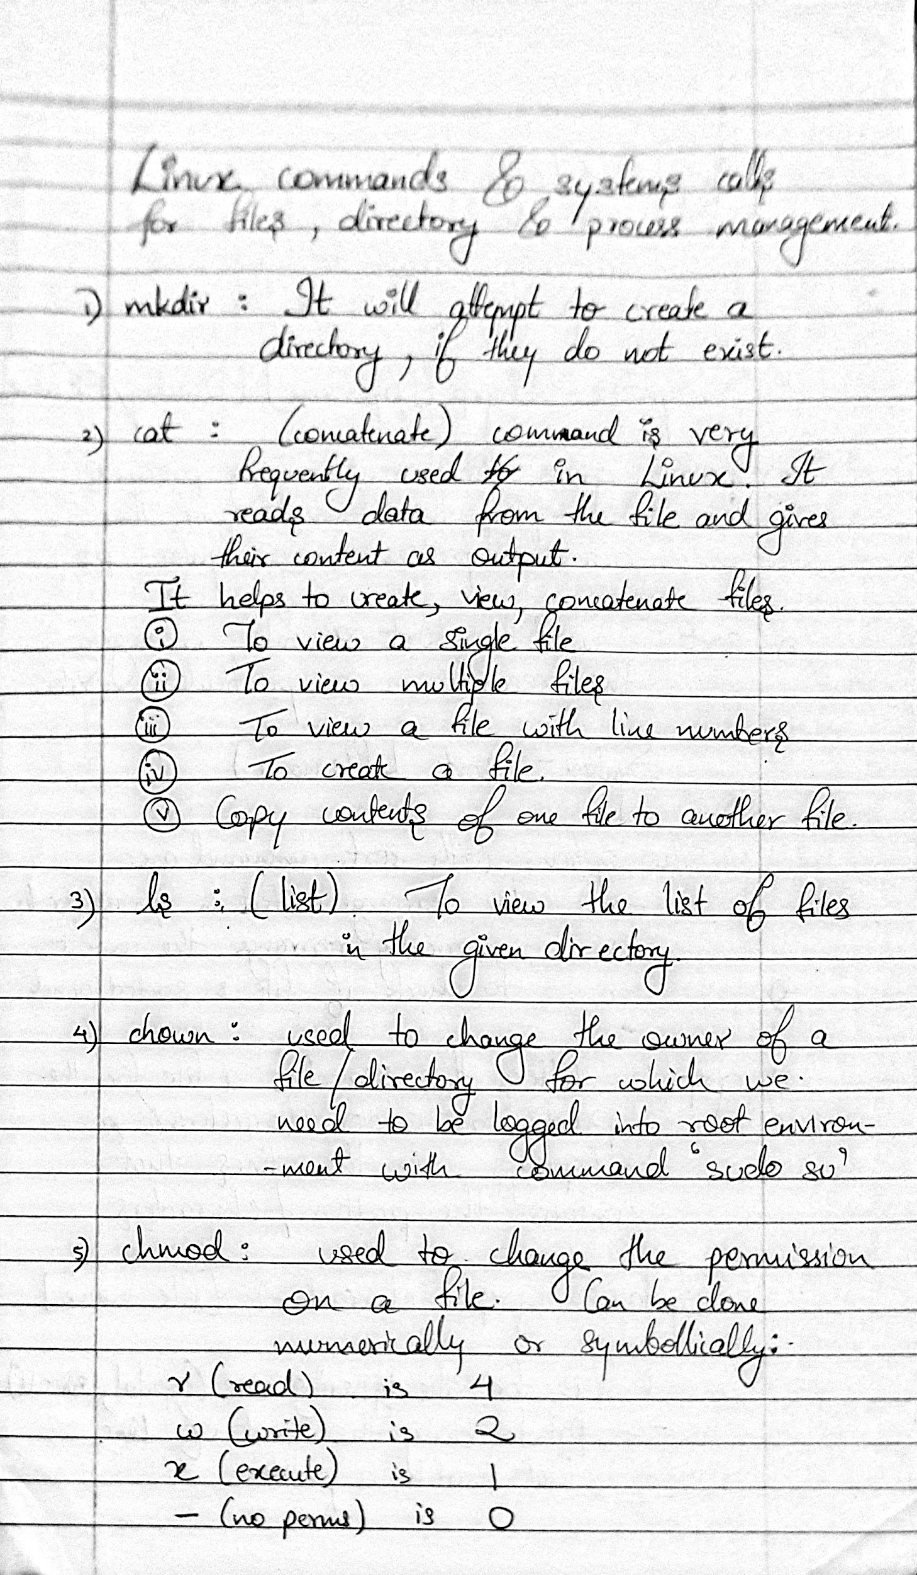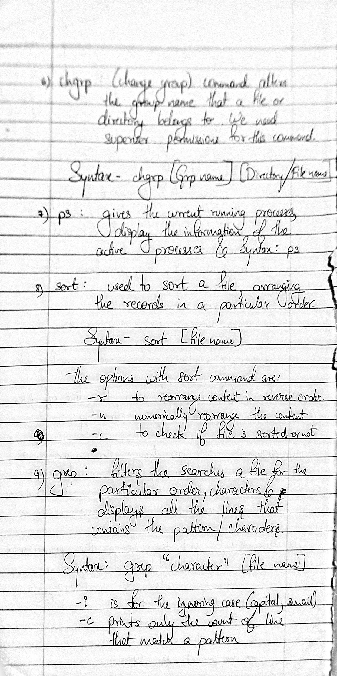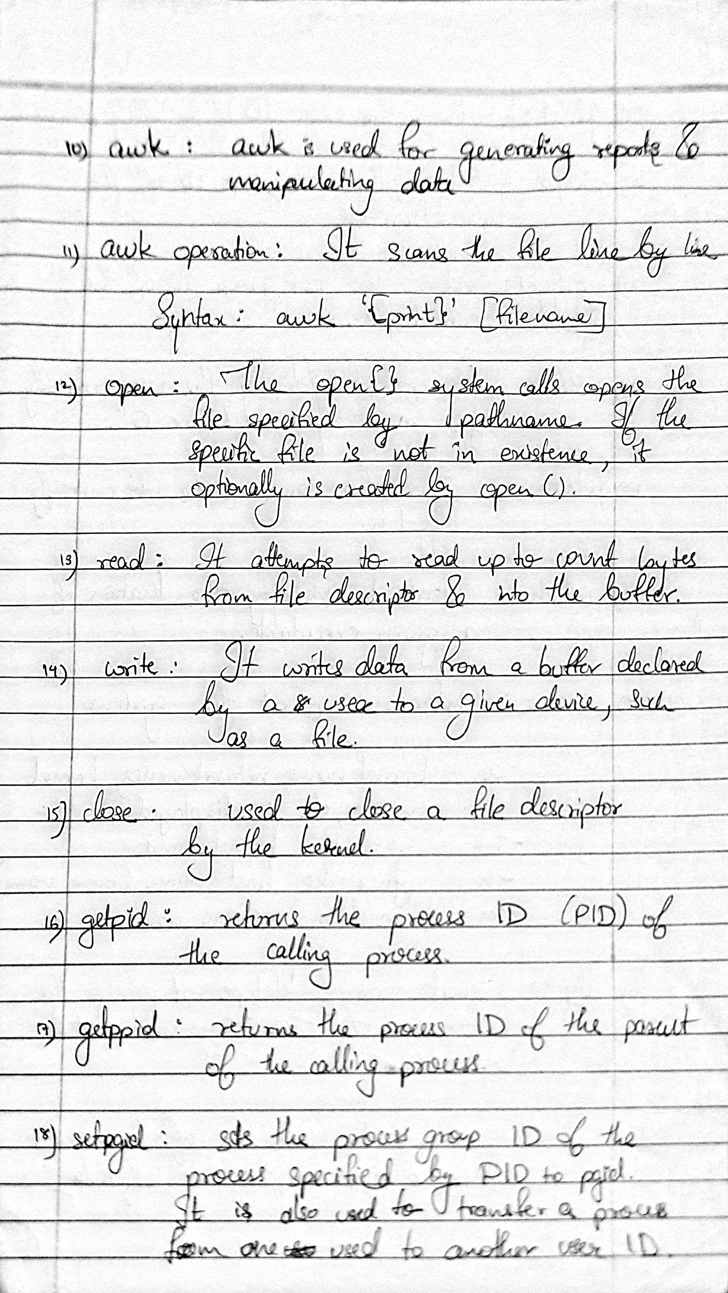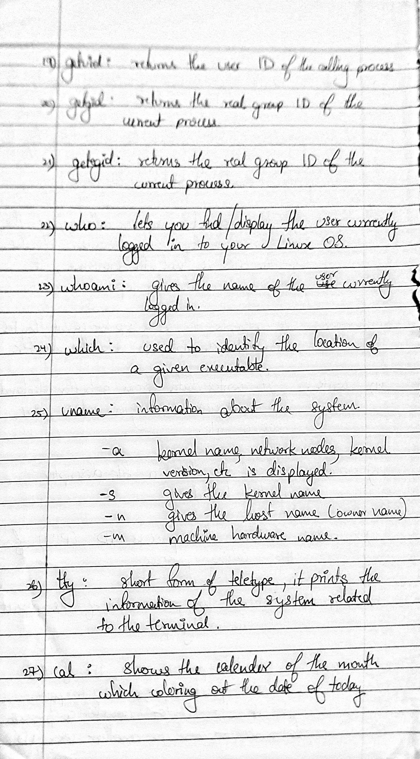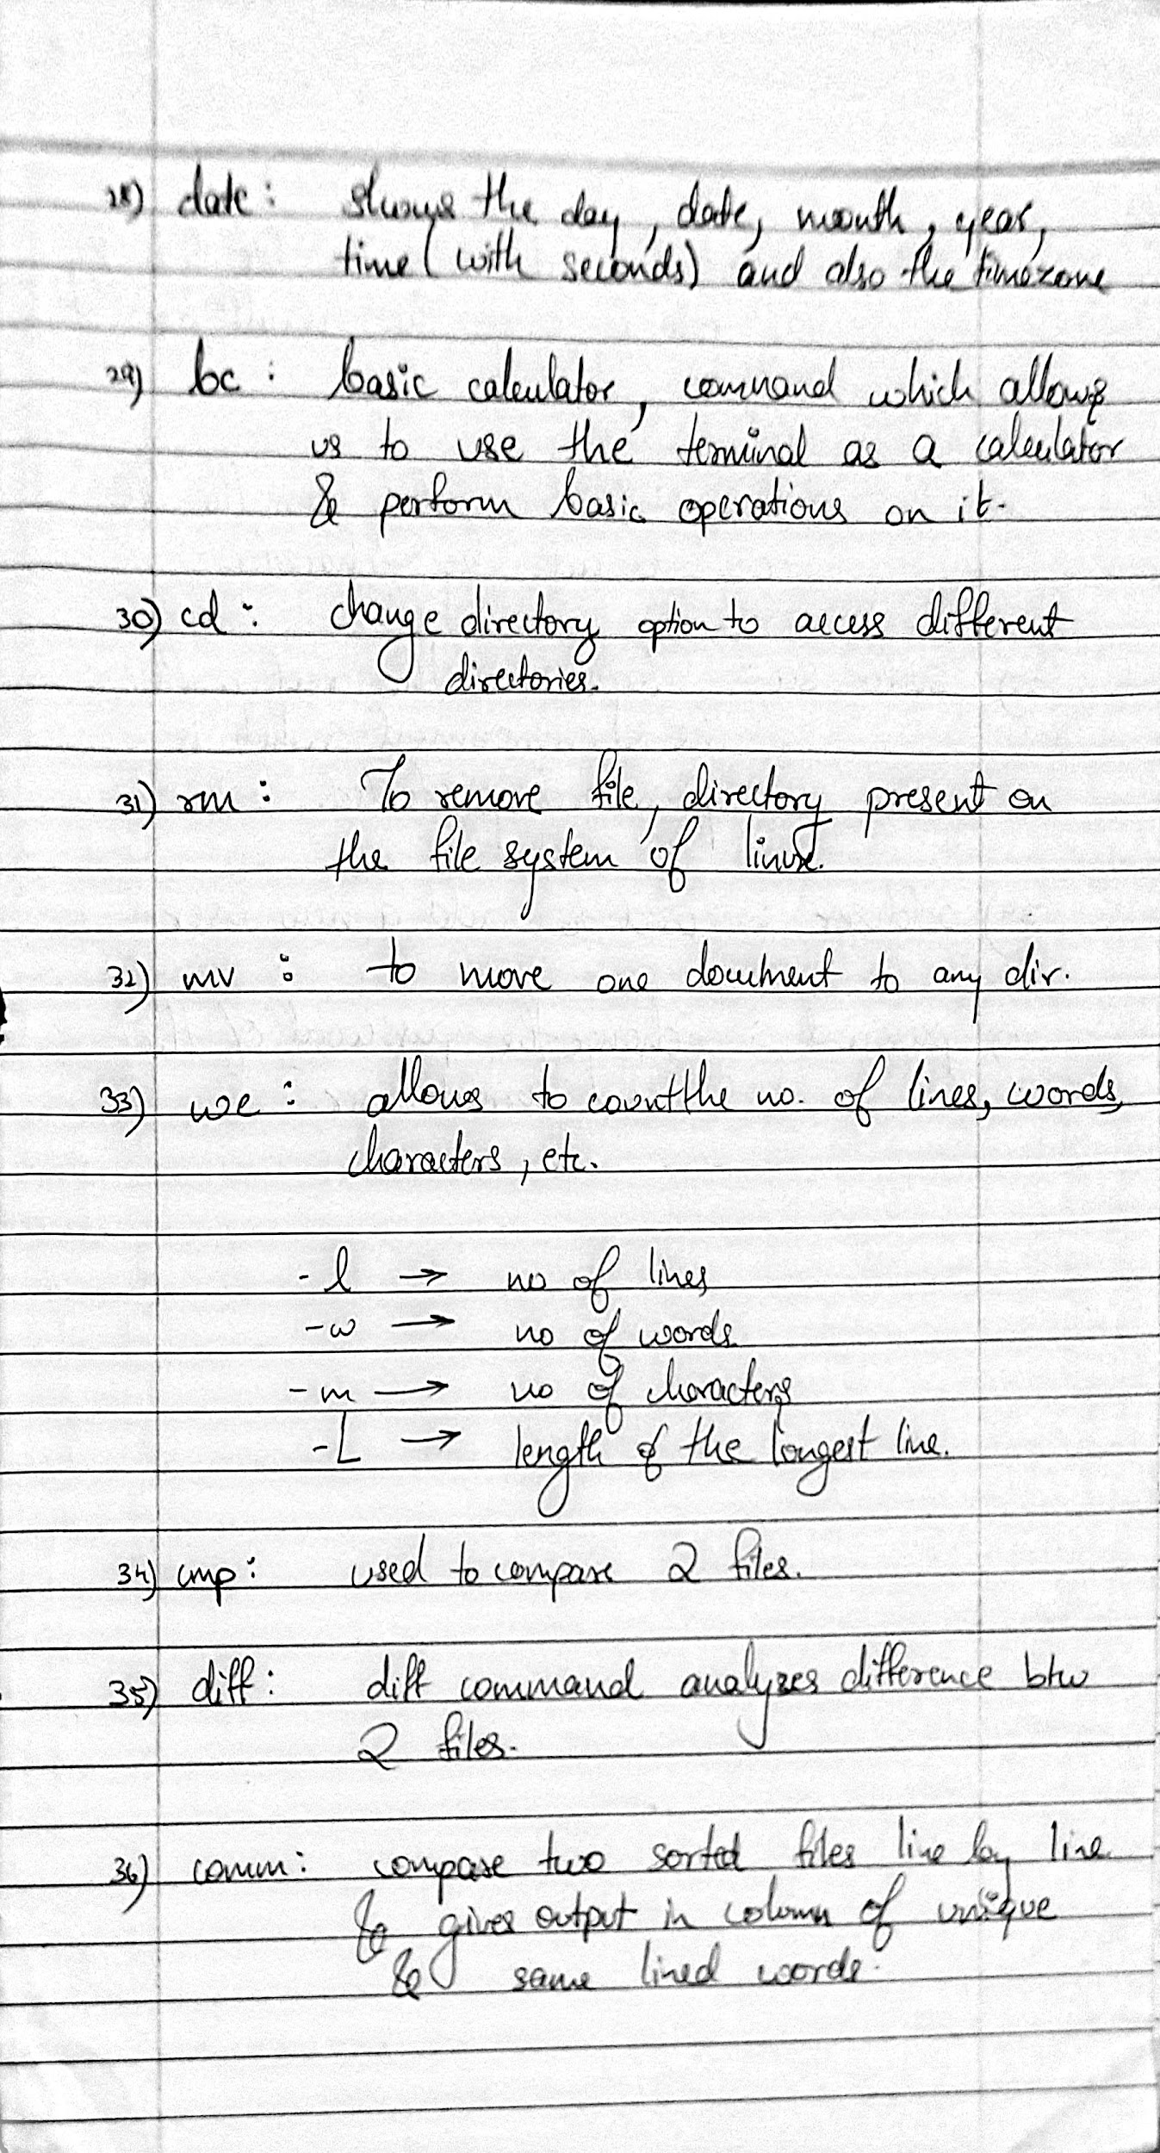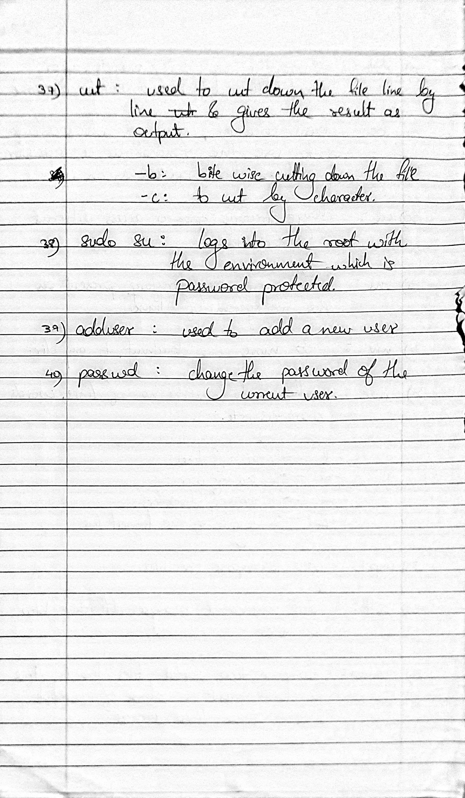

**___________________________________________________**

**Snippets:**

includes Mkdir, Cat, ls, Chown, Chmod, Chgrp, Ps, Sort, Grep, Awk, Who, Whoami, Which, Uname, Tty, Date, Cal , Bc, Mv, Wc, Cmp, Diff.

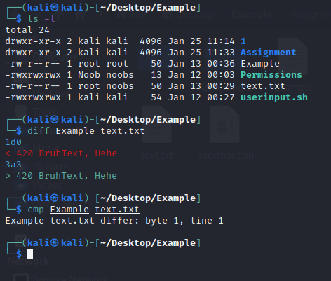

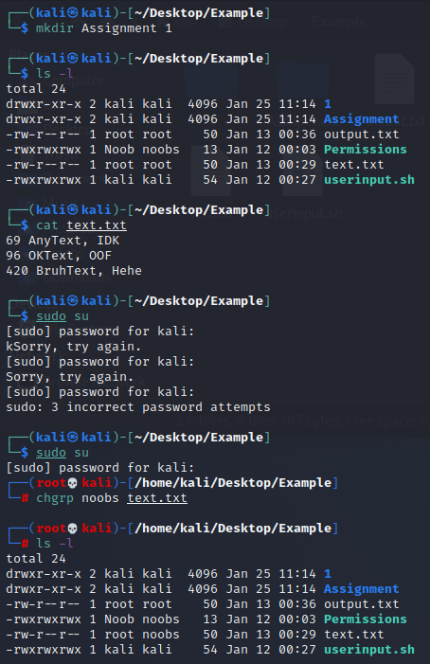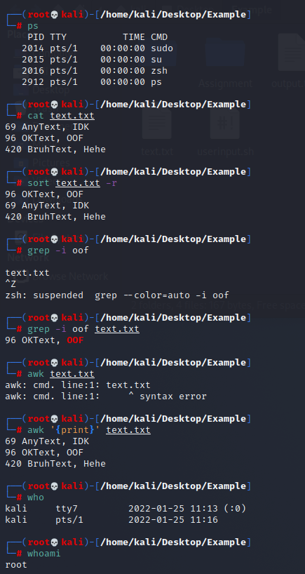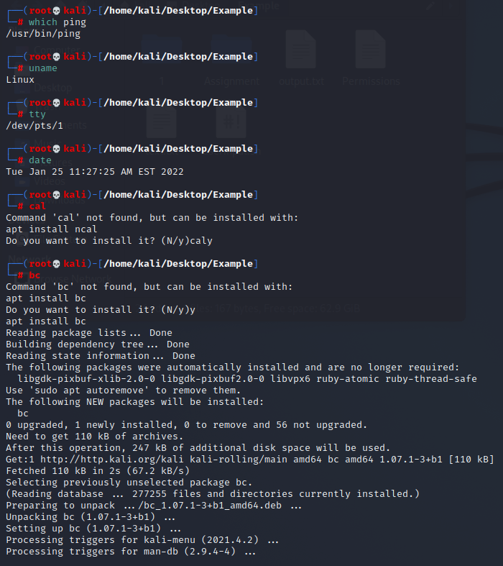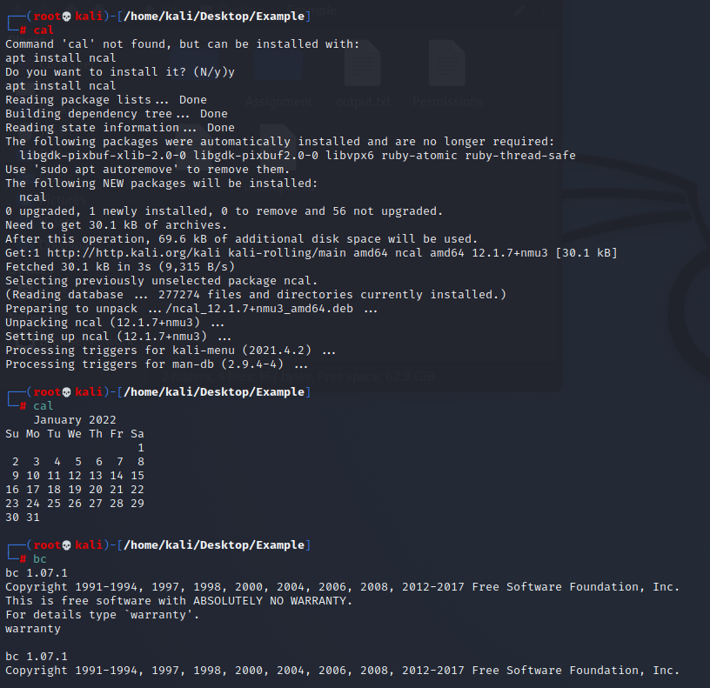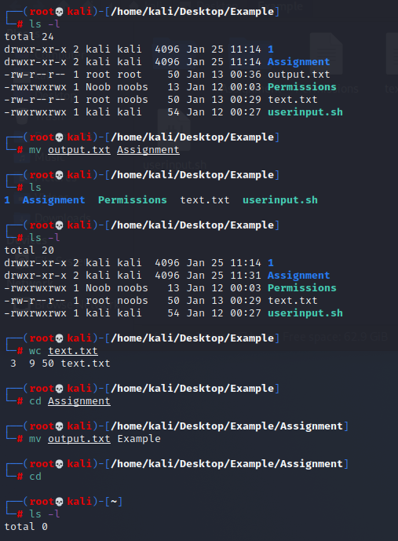

**___________________________________________________**

Conclusion:-

Thus we can use the following commands and get more options about them by using ‘man’ or ‘--help’ commands and learn in depth about them.

**___________________________________________________**